Operating System
Name：Yin Yuang | STU_NO：202383930027 | Exp：4-5

Experiment4:Banker’s Algorithm
Experimental Purpose
1.Gain a thorough understanding of the basic principles and implementation mechanisms of the Banker's Algorithm, and master the core ideas of resource allocation and deadlock avoidance.
2.Learn how to implement the Banker's Algorithm through programming, including key steps such as system initialization, resource request processing, and safety check.
3.Verify the effectiveness of the Banker's Algorithm in avoiding deadlocks during dynamic resource allocation, and observe the generation process of the safe sequence.
4.Cultivate students' system design capabilities and programming practice skills, and enhance their understanding of the resource management mechanism of operating systems.
Experimental Content
1.Algorithm Implementation Core
This experiment implements the Banker's Algorithm in C, with three modular core functions:
- is_safe(): The core function for safety check. It initializes the work vector with available resources, traverses processes to find executable ones (whose need ≤ work), releases their allocated resources after execution, and generates a safe sequence.
- init_system(): Reads user input (resource types, total resources, process count, Max and Allocation matrices), calculates the Need matrix (Need = Max - Allocation) and Available vector (Available = Total - sum of Allocation), and validates data legality.
- request_resources(): Handles dynamic resource requests with two legality checks, tentative allocation, safety recheck, and rollback mechanism for unsafe states.
2.Experimental Configuration
To focus on verifying the core mechanism of the Banker's Algorithm, the experiment uses a simplified but representative system configuration, with clear process and resource definitions as follows:
Configuration Item | Specific Content
Number of Processes | 2 processes, numbered P₀ and P₁ respectively
Number of Resource Types | 3 types, marked as A, B, C
Total Resources (A, B, C) | (10, 5, 7) — total amount of each resource in the system
Max Matrix (P₀ / P₁) | (7, 5, 3) / (3, 2, 2) — maximum resource demand of each process
Initial Allocation Matrix (P₀ / P₁) | (0, 1, 0) / (2, 0, 0) — initially allocated resources of each process
Calculated Need Matrix (P₀ / P₁) | (7, 4, 3) / (1, 2, 2) — remaining resource demand of each process
3.Key Experimental Steps & Results
The experiment follows the core process of "initialization → safety check → dynamic request simulation → edge case verification" to complete the test, and the key steps and corresponding results are as follows:
3.1 Initial Safety Check
Execute is_safe(): Work vector starts as (8,4,7). P₀ executes first (Need ≤ Work), Work updates to (8,5,7); then P₁ executes, Work updates to (10,5,7).
3.2 Dynamic Resource Request Simulation
Take the resource request initiated by process P₁ as the test object, and verify the complete processing flow of the algorithm for legal requests:
Step | Key Operation | Execution Details & Result
1 | Initiate Request | P₁ submits a resource request (1, 0, 2)
2 | Legality Check | 1. Request ≤ Need(P₁): (1,0,2) ≤ (1,2,2) ; 2. Request ≤ Available: (1,0,2) ≤ (8,4,7) . The request is legal.
3 | Tentative Allocation | Update system state: Available = (8-1, 4-0, 7-2) = (7, 4, 5); Allocation(P₁) = (2+1, 0+0, 0+2) = (3, 0, 2); Need(P₁) = (1-1, 2-0, 2-2) = (0, 2, 0).
4 | Safety Recheck | Call is_safe() again: Work = (7,4,5). P₀'s Need (7,4,3) ≤ Work, execute P₀ to update Work to (7,5,5); then execute P₁, Work returns to total resources. System remains safe.
5 | Final Decision | Confirm the allocation, and the updated system state takes effect.
4.Edge Case Verification
To fully verify the robustness of the algorithm, three typical edge cases are designed for testing, and the processing results are as follows:
Edge Case | Test Scenario | Experimental Result
Request > Need | P₁ requests (2,0,2) | Request denied immediately
Request > Available | P₀ requests (9,0,0) | Process blocked
Post-allocation Unsafe State | Legal request leading to no safe sequence | System rolls back and denies request
Experimental Result
1.Initial System State
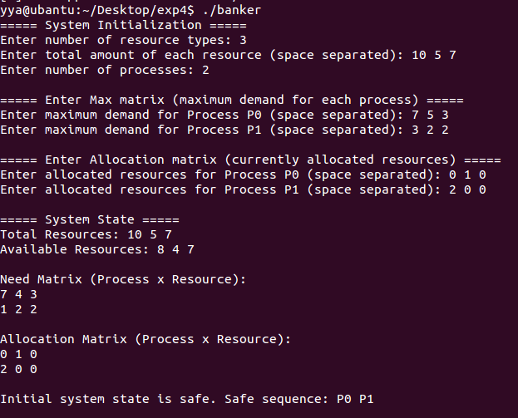
Figure 1. Screenshot of Initial System State
This screenshot records the initial state of the system after initialization. The physical memory is represented by resource matrices:
Resource Indicator | Specific Content
Total Resources | (10, 5, 7)
Available Resources | (8, 4, 7)
Need Matrix (P₀/P₁) | (7, 4, 3) / (1, 2, 2)
Allocation Matrix (P₀/P₁) | (0, 1, 0) / (2, 0, 0)
The initial safety check confirms the system is in a safe state with the safe sequence P0 P1, indicating no deadlock risk initially.
2.Dynamic Resource Request Simulation
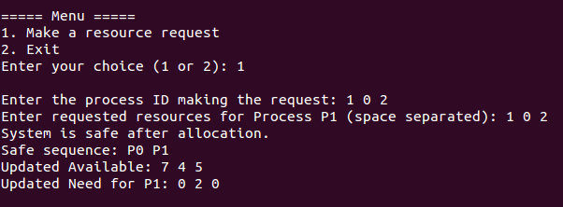
Figure 2. Screenshot of Legal Request Allocation
First, the algorithm completes two legality checks: the request does not exceed P₁'s remaining need (1 ≤ 1 for resource A), nor does it exceed the current available resources (1 ≤ 8 for resource A). Then, the algorithm performs a tentative allocation (updating Available to (7, 4, 5)), and rechecks the safety state— the safe sequence (P₀ P₁) is still valid. Finally, the allocation is confirmed.
This process demonstrates the complete workflow of the Banker's Algorithm: "legality verification → tentative allocation → safety check → formal allocation", which ensures that resource allocation will not lead to system insecurity.
3.Illegal Request Handling
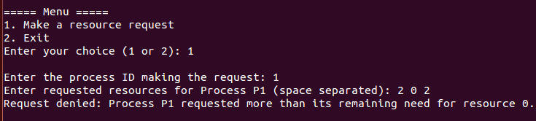
Figure 3. Screenshot of Request Exceeding Need
The screenshot shows Process P₁ initiating a request (2, 0, 2). The algorithm directly denies the request, with the prompt "Process P1 requested more than its remaining need for resource 0".
This result reflects the legality filter mechanism of the Banker's Algorithm: the request of a process cannot exceed its maximum remaining need (Need). This mechanism avoids logical conflicts in resource requests (e.g., a process requesting more resources than it actually requires), ensuring the rationality of the system's resource demand.
4 Resource Unavailability Handling
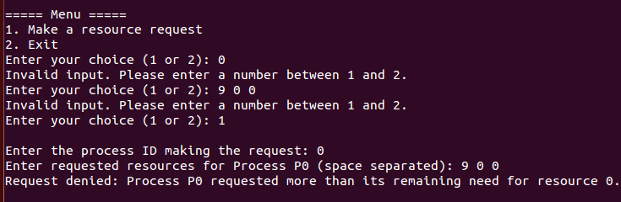
Figure 4. Screenshot of Request Exceeding Available Resources
The screenshot shows Process P0 initiating a request (9, 0, 0) after the previous allocation. The algorithm denies the request and blocks the process, with the prompt "Resources unavailable. Process P0 will be blocked".
This result reflects the resource supply-demand coordination mechanism of the Banker's Algorithm: when the available resources are insufficient to meet the request, the process is blocked (rather than forced to allocate) to avoid the exhaustion of system resources. This ensures that the system can maintain basic resource supply capacity for other processes.

Experiment5:Memory Management
Experimental Purpose
1.Understand the core principles of dynamic memory allocation and reclamation, and master the implementation logic of the First Fit algorithm.
2.Simulate the partition management mechanism of physical memory, including key operations such as free block merging, memory block splitting, resource allocation and reclamation.
3.Implement the memory status monitoring function, which can count the total free memory, the number of free blocks, the size of the largest free block and the external fragmentation rate.
4.Verify the effectiveness and stability of the memory allocation algorithm through random simulation experiments, and observe the generation and variation rules of memory fragments.
Experimental Content
1.Data Structures
Two core data structures are used in the simulator: Segment (logical memory unit) and MemoryBlock (physical memory unit). Their key attributes are summarized below.
Structure | Attributes | Description
Segment | segId | Unique logical segment identifier
Segment | size | Requested memory size (KB)
MemoryBlock | segId | Segment bound to the block (−1 for free block)
MemoryBlock | startAddr | Starting physical memory address
MemoryBlock | size | Block size (KB)
MemoryBlock | isAllocated | Allocation status (true = allocated, false = free)
2.Memory Initialization
At program startup, the simulator initializes the physical memory as a single free block of 1024 KB, representing an empty continuous memory space.
Additionally:
- A segment ID counter is prepared to generate unique IDs for each allocated segment.
- A random seed is initialized to support the randomized behavior used in the simulation stage.
This setup provides a clean and controlled environment for observing how memory allocation evolves over time.
3.Core Functionality
3.1 Memory Allocation(First-Fit Strategy)
When a memory request is issued, the First-Fit algorithm scans the memory blocks sequentially and selects the first free block large enough to satisfy the request:
- Exact match—If block size equals the request size, the block is allocated directly.
- Splitting—If the block is larger, it is split into one allocated block matching the requested size or a smaller remaining free block
- Failure—If no free block can satisfy the request, allocation fails.
This demonstrates how First-Fit prioritizes low search time but may lead to fragmentation.
3.2 Memory Deallocation and Block Merging
Memory is released by specifying its segment ID.
After a block is marked as free, the simulator invokes a coalescing procedure that merges all adjacent free blocks to reduce external fragmentation.This behavior mimics real operating systems, where coalescing is essential to maintain larger continuous free regions.
3.3 Memory Statistics and Visualization
The simulator provides information on total memory, free memory, number of free blocks, largest free block, and external fragmentation.
Metric | Description
Total memory | Fixed at 1024 KB
Free memory | Sum of all free block sizes
Allocated memory | Memory currently in use
Number of free blocks | Indicator of system fragmentation
Largest free block | Reflects availability of large contiguous space
External fragmentation | Measures scattering of free memory
External fragmentation is calculated as:
$$\text{FragRate=}\frac{\text{Total Free Memory−Largest Free Block}}{\text{Total Free Memory}}\text{×100\%}$$
The simulator also prints a memory block table, making the allocation status and fragmentation visually observable.
4.Random Simulation
A multi-round randomized simulation is performed, alternating between:
- random-sized memory allocations
- random deallocations
This process emulates a real operating environment, allowing us to observe:
- how memory fragments over time
- how often First-Fit succeeds or fails
- how block merging mitigates fragmentation
The random simulation provides insight into the long-term performance and limitations of dynamic partition allocation strategies.
Experimental Results
This experiment simulates the dynamic partition allocation and reclamation process of a 1024KB physical memory based on the First-Fit algorithm. By conducting multiple rounds of random requests, the changes in memory status are observed, and the specific results are as follows:
1.Initial Memory Status
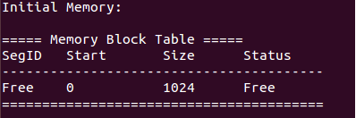
Figure1. Screenshot of Initial Memory Status
This screenshot records the memory block table at the start of the experiment: the physical memory is initialized as a continuous free block with SegID marked as "Free", starting address 0, size 1024KB, and status Free, presenting an initial state without fragmentation.
2.Multi-Round Random Allocation and Reclamation Process
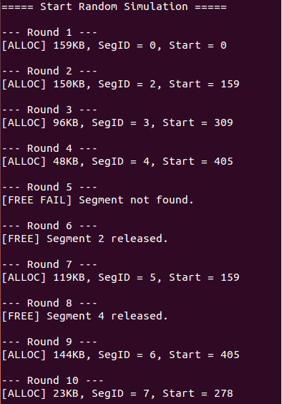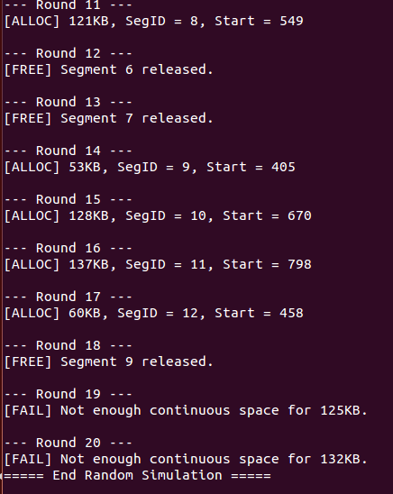
Figure2. Screenshot of Round 1-20 Simulation Process
This screenshot shows the execution process of all 20 rounds of random operations. The details of each round are presented in the table below:
Round | Operation Type | Specific Operation Content | Result Description
1 | Allocation | Request 159KB | Success. First-Fit selects the first free block (the initial 1024KB block)
2 | Allocation | Request 150KB | Success. First-Fit selects the remaining free block (the 865KB block)
3 | Allocation | Request 96KB | Success. First-Fit selects the remaining free block (the 715KB block)
4 | Allocation | Request 48KB | Success. First-Fit selects the remaining free block (the 619KB block)
5 | Reclamation | Release a non-existent segment | Failure. Invalid segment ID
6 | Reclamation | Release Segment 2 (150KB) | Success. A 150KB free block is formed
7 | Allocation | Request 119KB | Success. The free block released by Segment 2 is split, with 31KB remaining
8 | Reclamation | Release Segment 4 (48KB) | Success. A 48KB free block is formed
9 | Allocation | Request 144KB | Success. First-Fit selects the corresponding free block
10 | Allocation | Request 23KB | Success. First-Fit selects the corresponding free block
11 | Allocation | Request 121KB | Success. First-Fit selects the corresponding free block
12 | Reclamation | Release Segment 6 | Success. A free block of corresponding size is formed
13 | Reclamation | Release Segment 7 | Success. A free block of corresponding size is formed
14 | Allocation | Request 53KB | Success. First-Fit selects the corresponding free block
15 | Allocation | Request 128KB | Success. First-Fit selects the corresponding free block
16 | Allocation | Request 137KB | Success. First-Fit selects the corresponding free block
17 | Allocation | Request 60KB | Success. First-Fit selects the corresponding free block
18 | Reclamation | Release Segment 9 | Success. A free block of corresponding size is formed
19 | Allocation | Request 125KB | Failure. Insufficient continuous free space
20 | Allocation | Request 132KB | Failure. Insufficient continuous free space
3.Memory Statistics and Final Block Table
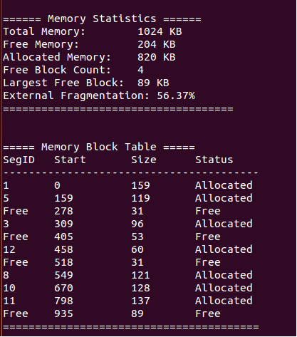
Figure3. Screenshot of Memory Statistics and Final Memory Block Table
This screenshot displays the memory statistics and the final memory block table upon the completion of the experiment. The statistical indicators show that the total memory is 1024KB, free memory is 204KB, allocated memory is 820KB, the number of free blocks is 4, the size of the largest free block is 89KB, and the external fragmentation rate reaches 56.37%. Meanwhile, the final memory block table exhibits obvious characteristics of fragmented distribution—allocated blocks and free blocks exist alternately, with the four free blocks of 31KB, 53KB, 31KB and 89KB scattered among the allocated blocks, failing to form a continuous large free space that can be used for large memory requests.

Appendix: Experimental Codes​
Appendix A: Code for Experiment 4 (Banker's Algorithm)
#include <stdio.h>
#include <stdlib.h>
#include <stdbool.h>
#include <string.h>
#define MAX_PROCESS 10
#define MAX_RESOURCE 10
#define BUFFER_SIZE 100
int process_num;
int resource_num;
int total_resources[MAX_RESOURCE];
int allocation[MAX_PROCESS][MAX_RESOURCE];
int max[MAX_PROCESS][MAX_RESOURCE];
int need[MAX_PROCESS][MAX_RESOURCE];
int available[MAX_RESOURCE];
// Function to check system safety
bool is_safe(int safe_seq[]) {
int finish[MAX_PROCESS] = {0};
int work[MAX_RESOURCE];
// Initialize work with available resources
for (int i = 0; i < resource_num; i++) {
work[i] = available[i];
}
int count = 0;
while (count < process_num) {
bool found = false;
for (int i = 0; i < process_num; i++) {
if (!finish[i]) {
bool can_allocate = true;
// Check if all resources can be allocated
for (int j = 0; j < resource_num; j++) {
if (need[i][j] > work[j]) {
can_allocate = false;
break;
}
}
if (can_allocate) {
// Allocate resources and mark process as finished
for (int j = 0; j < resource_num; j++) {
work[j] += allocation[i][j];
}
safe_seq[count++] = i;
finish[i] = 1;
found = true;
}
}
}
if (!found) {
break; // No more processes can be allocated
}
}
// Check if all processes are finished
for (int i = 0; i < process_num; i++) {
if (!finish[i]) {
return false;
}
}
return true;
}
// Function to read integer input safely
int read_int(const char *prompt, int min, int max) {
char buffer[BUFFER_SIZE];
int value;
while (1) {
printf("%s", prompt);
if (!fgets(buffer, sizeof(buffer), stdin)) {
continue;
}
if (sscanf(buffer, "%d", &value) == 1 && value >= min && value <= max) {
return value;
}
printf("Invalid input. Please enter a number between %d and %d.\n", min, max);
}
}
// Function to read array input safely
void read_int_array(const char *prompt, int arr[], int size, int min_val, int max_val) {
char buffer[BUFFER_SIZE];
while (1) {
printf("%s", prompt);
if (!fgets(buffer, sizeof(buffer), stdin)) {
continue;
}
int count = 0;
char *token = strtok(buffer, " \t\n");
bool valid = true;
while (token && count < size) {
int val;
if (sscanf(token, "%d", &val) != 1 || val < min_val || (max_val != -1 && val > max_val)
) {
valid = false;
break;
}
arr[count++] = val;
token = strtok(NULL, " \t\n");
}
if (valid && count == size) {
return;
}
if (max_val == -1) {
printf("Invalid input. Please enter %d non-negative integers.\n", size);
} else {
printf("Invalid input. Please enter %d integers between %d and %d.\n", size, min_val,
max_val);
}
}
}
// Initialize system
void init_system() {
printf("===== System Initialization =====\n");
// Read number of resource types
resource_num = read_int("Enter number of resource types: ", 1, MAX_RESOURCE);
// Read total amount of each resource
read_int_array("Enter total amount of each resource (space separated): ", total_resources, resource_num, 0, -1);
// Read number of processes
process_num = read_int("Enter number of processes: ", 1, MAX_PROCESS);
// Read Max matrix
printf("\n===== Enter Max matrix (maximum demand for each process) =====\n");
for (int i = 0; i < process_num; i++) {
char prompt[BUFFER_SIZE];
snprintf(prompt, sizeof(prompt), "Enter maximum demand for Process P%d (space separa
ted): ", i);
read_int_array(prompt, max[i], resource_num, 0, -1);
}
// Read Allocation matrix
printf("\n===== Enter Allocation matrix (currently allocated resources) =====\n");
for (int i = 0; i < process_num; i++) {
char prompt[BUFFER_SIZE];
snprintf(prompt, sizeof(prompt), "Enter allocated resources for Process P%d (space separa
ted): ", i);
read_int_array(prompt, allocation[i], resource_num, 0, -1);
}
// Compute Need matrix and validate
for (int i = 0; i < process_num; i++) {
for (int j = 0; j < resource_num; j++) {
need[i][j] = max[i][j] - allocation[i][j];
if (need[i][j] < 0) {
printf("Error: Process P%d allocated more than its maximum demand for resource %
d.\n", i, j);
printf("Program will exit. Please restart and enter valid values.\n");
exit(1);
}
}
}
// Compute Available vector and validate
for (int j = 0; j < resource_num; j++) {
int sum_alloc = 0;
for (int i = 0; i < process_num; i++) {
sum_alloc += allocation[i][j];
}
available[j] = total_resources[j] - sum_alloc;
if (available[j] < 0) {
printf("Error: Allocated resources exceed total resources for resource %d.\n", j);
printf("Program will exit. Please restart and enter valid values.\n");
exit(1);
}
}
// Print system state
printf("\n===== System State =====\n");
printf("Total Resources: ");
for (int j = 0; j < resource_num; j++) {
printf("%d", total_resources[j]);
if (j < resource_num - 1) {
printf(" ");
}
}
printf("\n");
printf("Available Resources: ");
for (int j = 0; j < resource_num; j++) {
printf("%d", available[j]);
if (j < resource_num - 1) {
printf(" ");
}
}
printf("\n");
printf("\nNeed Matrix (Process x Resource):\n");
for (int i = 0; i < process_num; i++) {
for (int j = 0; j < resource_num; j++) {
printf("%d", need[i][j]);
if (j < resource_num - 1) {
printf(" ");
}
}
printf("\n");
}
printf("\nAllocation Matrix (Process x Resource):\n");
for (int i = 0; i < process_num; i++) {
for (int j = 0; j < resource_num; j++) {
printf("%d", allocation[i][j]);
if (j < resource_num - 1) {
printf(" ");
}
}
printf("\n");
}
}
// Handle resource request
void request_resources() {
int p_id;
int request[MAX_RESOURCE];
int safe_seq[MAX_PROCESS];
// Read process ID
p_id = read_int("\nEnter the process ID making the request: ", 0, process_num - 1);
// Read requested resources
char prompt[BUFFER_SIZE];
snprintf(prompt, sizeof(prompt), "Enter requested resources for Process P%d (space separated): ", p_id);
read_int_array(prompt, request, resource_num, 0, -1);
// Check if request exceeds Need
for (int j = 0; j < resource_num; j++) {
if (request[j] > need[p_id][j]) {
printf("Request denied: Process P%d requested more than its remaining need for resour
ce %d.\n", p_id, j);
return;
}
}
// Check if request exceeds Available
for (int j = 0; j < resource_num; j++) {
if (request[j] > available[j]) {
printf("Request denied: Resources unavailable. Process P%d will be blocked.\n", p_id);
return;
}
}
// Try allocation
for (int j = 0; j < resource_num; j++) {
available[j] -= request[j];
allocation[p_id][j] += request[j];
need[p_id][j] -= request[j];
}
// Check if system is safe after allocation
if (is_safe(safe_seq)) {
printf("System is safe after allocation.\n");
printf("Safe sequence: ");
for (int i = 0; i < process_num; i++) {
printf("P%d", safe_seq[i]);
if (i < process_num - 1) {
printf(" ");
}
}
printf("\n");
printf("Updated Available: ");
for (int j = 0; j < resource_num; j++) {
printf("%d", available[j]);
if (j < resource_num - 1) {
printf(" ");
}
}
printf("\n");
printf("Updated Need for P%d: ", p_id);
for (int j = 0; j < resource_num; j++) {
printf("%d", need[p_id][j]);
if (j < resource_num - 1) {
printf(" ");
}
}
printf("\n");
} else {
// Rollback allocation
for (int j = 0; j < resource_num; j++) {
available[j] += request[j];
allocation[p_id][j] -= request[j];
need[p_id][j] += request[j];
}
printf("System would be unsafe! Request denied, state rolled back.\n");
}
}
int main() {
int choice;
int safe_seq[MAX_PROCESS];
// Initialize system
init_system();
// Check initial system safety
if (is_safe(safe_seq)) {
printf("\nInitial system state is safe. Safe sequence: ");
for (int i = 0; i < process_num; i++) {
printf("P%d", safe_seq[i]);
if (i < process_num - 1) {
printf(" ");
}
}
} else {
printf("\nInitial system state is not safe!");
}
printf("\n");
// Menu loop
while (1) {
printf("\n===== Menu =====\n");
printf("1. Make a resource request\n");
printf("2. Exit\n");
choice = read_int("Enter your choice (1 or 2): ", 1, 2);
if (choice == 1) {
request_resources();
} else if (choice == 2) {
printf("Program exiting.\n");
break;
}
}
return 0;
}

Appendix B: Code for Experiment 5 (Memory Management)
#include <iostream>
#include <vector>
#include <cstdlib>
#include <ctime>
#include <iomanip>
#include <algorithm>
using namespace std;
/* ---------------- Segment and Memory Block Definitions ---------------- */
// Logical segment (just for demonstration)
struct Segment {
int segId;
int size;
};
// Physical memory block (free or allocated)
struct MemoryBlock {
int segId; // Segment ID (-1 means free)
int startAddr;
int size; // Size in KB
bool isAllocated;
};
/* ---------------- Global Variables ---------------- */
vector<MemoryBlock> memoryBlocks; // physical memory
const int TOTAL_MEMORY = 1024; // 1 MB
int nextSegId = 1; // auto-increment segment ID
int randomSeed = time(0);
/* ---------------- Initialization ---------------- */
void initMemory() {
memoryBlocks.clear();
MemoryBlock block;
block.segId = -1;
block.startAddr = 0;
block.size = TOTAL_MEMORY;
block.isAllocated = false;
memoryBlocks.push_back(block);
srand(randomSeed);
}
/* ---------------- Coalescing Free Blocks ---------------- */
void mergeFreeBlocks() {
vector<MemoryBlock> newList;
for (int i = 0; i < memoryBlocks.size(); i++) {
MemoryBlock cur = memoryBlocks[i];
if (!cur.isAllocated) {
while (i + 1 < memoryBlocks.size() &&
!memoryBlocks[i+1].isAllocated) {
cur.size += memoryBlocks[i+1].size;
i++;
}
}
newList.push_back(cur);
}
memoryBlocks = newList;
}
/* ---------------- First Fit Allocation ---------------- */
int allocate(int size) {
if (size <= 0 || size > TOTAL_MEMORY) {
cout << "Invalid allocation size.\n";
return -1;
}
for (int i = 0; i < memoryBlocks.size(); i++) {
MemoryBlock &blk = memoryBlocks[i];
if (!blk.isAllocated && blk.size >= size) {
if (blk.size == size) {
blk.isAllocated = true;
blk.segId = nextSegId++;
cout << "[ALLOC] " << size << "KB, SegID = " << blk.segId
<< ", Start = " << blk.startAddr << endl;
return blk.segId;
}
// Split block
MemoryBlock newFree;
newFree.segId = -1;
newFree.startAddr = blk.startAddr + size;
newFree.size = blk.size - size;
newFree.isAllocated = false;
blk.size = size;
blk.isAllocated = true;
blk.segId = nextSegId++;
memoryBlocks.insert(memoryBlocks.begin() + i + 1, newFree);
cout << "[ALLOC] " << size << "KB, SegID = " << blk.segId
<< ", Start = " << blk.startAddr << endl;
return blk.segId;
}
}
cout << "[FAIL] Not enough continuous space for " << size << "KB.\n";
return -1;
}
/* ---------------- Deallocate Segment ---------------- */
bool deallocate(int segId) {
for (auto &blk : memoryBlocks) {
if (blk.segId == segId && blk.isAllocated) {
blk.segId = -1;
blk.isAllocated = false;
cout << "[FREE] Segment " << segId << " released.\n";
mergeFreeBlocks();
return true;
}
}
cout << "[FREE FAIL] Segment not found.\n";
return false;
}
/* ---------------- Memory Statistics ---------------- */
void memoryStats() {
int freeTotal = 0, freeBlocks = 0, maxFree = 0;
for (auto &blk : memoryBlocks) {
if (!blk.isAllocated) {
freeBlocks++;
freeTotal += blk.size;
maxFree = max(maxFree, blk.size);
}
}
double fragRate =
(freeTotal > 0 ? (freeTotal - maxFree) * 100.0 / freeTotal : 0.0);
cout << "\n====== Memory Statistics ======\n";
cout << "Total Memory: 1024 KB\n";
cout << "Free Memory: " << freeTotal << " KB\n";
cout << "Allocated Memory: " << TOTAL_MEMORY - freeTotal << " KB\n";
cout << "Free Block Count: " << freeBlocks << "\n";
cout << "Largest Free Block: " << maxFree << " KB\n";
cout << fixed << setprecision(2);
cout << "External Fragmentation: " << fragRate << "%\n";
cout << "====================================\n\n";
}
/* ---------------- Print Memory Blocks ---------------- */
void printMemory() {
cout << "\n===== Memory Block Table =====\n";
cout << left << setw(8) << "SegID"
<< setw(12) << "Start"
<< setw(10) << "Size"
<< setw(12) << "Status" << endl;
cout << "----------------------------------------\n";
for (auto &blk : memoryBlocks) {
cout << left
<< setw(8) << (blk.segId == -1 ? string("Free") : to_string(blk.segId))
<< setw(12) << blk.startAddr
<< setw(10) << blk.size
<< setw(12) << (blk.isAllocated ? "Allocated" : "Free")
<< endl;
}
cout << "========================================\n\n";
}
/* ---------------- Random Simulation ---------------- */
void simulateRandom(int rounds) {
vector<int> allocated;
cout << "\n===== Start Random Simulation =====\n";
for (int i = 1; i <= rounds; i++) {
cout << "\n--- Round " << i << " ---\n";
bool doAlloc = (allocated.empty() ? true : rand() % 2 == 0);
if (doAlloc) {
int size = 10 + rand() % 150;
int segId = allocate(size);
if (segId != -1) allocated.push_back(segId);
}
else {
int idx = rand() % allocated.size();
int segId = allocated[idx];
if (deallocate(segId)) {
allocated.erase(allocated.begin() + idx);
}
}
}
cout << "===== End Random Simulation =====\n\n";
}
/* ---------------- Main ---------------- */
int main() {
initMemory();
cout << "Initial Memory:\n";
printMemory();
simulateRandom(20);
memoryStats();
printMemory();
return 0;
}
#include <iostream>
#include <vector>
#include <cstdlib>
#include <ctime>
#include <iomanip>
#include <algorithm>
using namespace std;
/* ---------------- Segment and Memory Block Definitions ---------------- */
// Logical segment (just for demonstration)
struct Segment {
int segId;
int size;
};
// Physical memory block (free or allocated)
struct MemoryBlock {
int segId; // Segment ID (-1 means free)
int startAddr;
int size; // Size in KB
bool isAllocated;
};
/* ---------------- Global Variables ---------------- */
vector<MemoryBlock> memoryBlocks; // physical memory
const int TOTAL_MEMORY = 1024; // 1 MB
int nextSegId = 1; // auto-increment segment ID
int randomSeed = time(0);
/* ---------------- Initialization ---------------- */
void initMemory() {
memoryBlocks.clear();
MemoryBlock block;
block.segId = -1;
block.startAddr = 0;
block.size = TOTAL_MEMORY;
block.isAllocated = false;
memoryBlocks.push_back(block);
srand(randomSeed);
}
/* ---------------- Coalescing Free Blocks ---------------- */
void mergeFreeBlocks() {
vector<MemoryBlock> newList;
for (int i = 0; i < memoryBlocks.size(); i++) {
MemoryBlock cur = memoryBlocks[i];
if (!cur.isAllocated) {
while (i + 1 < memoryBlocks.size() &&
!memoryBlocks[i+1].isAllocated) {
cur.size += memoryBlocks[i+1].size;
i++;
}
}
newList.push_back(cur);
}
memoryBlocks = newList;
}
/* ---------------- First Fit Allocation ---------------- */
int allocate(int size) {
if (size <= 0 || size > TOTAL_MEMORY) {
cout << "Invalid allocation size.\n";
return -1;
}
for (int i = 0; i < memoryBlocks.size(); i++) {
MemoryBlock &blk = memoryBlocks[i];
if (!blk.isAllocated && blk.size >= size) {
if (blk.size == size) {
blk.isAllocated = true;
blk.segId = nextSegId++;
cout << "[ALLOC] " << size << "KB, SegID = " << blk.segId
<< ", Start = " << blk.startAddr << endl;
return blk.segId;
}
// Split block
MemoryBlock newFree;
newFree.segId = -1;
newFree.startAddr = blk.startAddr + size;
newFree.size = blk.size - size;
newFree.isAllocated = false;
blk.size = size;
blk.isAllocated = true;
blk.segId = nextSegId++;
memoryBlocks.insert(memoryBlocks.begin() + i + 1, newFree);
cout << "[ALLOC] " << size << "KB, SegID = " << blk.segId
<< ", Start = " << blk.startAddr << endl;
return blk.segId;
}
}
cout << "[FAIL] Not enough continuous space for " << size << "KB.\n";
return -1;
}
/* ---------------- Deallocate Segment ---------------- */
bool deallocate(int segId) {
for (auto &blk : memoryBlocks) {
if (blk.segId == segId && blk.isAllocated) {
blk.segId = -1;
blk.isAllocated = false;
cout << "[FREE] Segment " << segId << " released.\n";
mergeFreeBlocks();
return true;
}
}
cout << "[FREE FAIL] Segment not found.\n";
return false;
}
/* ---------------- Memory Statistics ---------------- */
void memoryStats() {
int freeTotal = 0, freeBlocks = 0, maxFree = 0;
for (auto &blk : memoryBlocks) {
if (!blk.isAllocated) {
freeBlocks++;
freeTotal += blk.size;
maxFree = max(maxFree, blk.size);
}
}
double fragRate =
(freeTotal > 0 ? (freeTotal - maxFree) * 100.0 / freeTotal : 0.0);
cout << "\n====== Memory Statistics ======\n";
cout << "Total Memory: 1024 KB\n";
cout << "Free Memory: " << freeTotal << " KB\n";
cout << "Allocated Memory: " << TOTAL_MEMORY - freeTotal << " KB\n";
cout << "Free Block Count: " << freeBlocks << "\n";
cout << "Largest Free Block: " << maxFree << " KB\n";
cout << fixed << setprecision(2);
cout << "External Fragmentation: " << fragRate << "%\n";
cout << "====================================\n\n";
}
/* ---------------- Print Memory Blocks ---------------- */
void printMemory() {
cout << "\n===== Memory Block Table =====\n";
cout << left << setw(8) << "SegID"
<< setw(12) << "Start"
<< setw(10) << "Size"
<< setw(12) << "Status" << endl;
cout << "----------------------------------------\n";
for (auto &blk : memoryBlocks) {
cout << left
<< setw(8) << (blk.segId == -1 ? string("Free") : to_string(blk.segId))
<< setw(12) << blk.startAddr
<< setw(10) << blk.size
<< setw(12) << (blk.isAllocated ? "Allocated" : "Free")
<< endl;
}
cout << "========================================\n\n";
}
/* ---------------- Random Simulation ---------------- */
void simulateRandom(int rounds) {
vector<int> allocated;
cout << "\n===== Start Random Simulation =====\n";
for (int i = 1; i <= rounds; i++) {
cout << "\n--- Round " << i << " ---\n";
bool doAlloc = (allocated.empty() ? true : rand() % 2 == 0);
if (doAlloc) {
int size = 10 + rand() % 150;
int segId = allocate(size);
if (segId != -1) allocated.push_back(segId);
}
else {
int idx = rand() % allocated.size();
int segId = allocated[idx];
if (deallocate(segId)) {
allocated.erase(allocated.begin() + idx);
}
}
}
cout << "===== End Random Simulation =====\n\n";
}
/* ---------------- Main ---------------- */
int main() {
initMemory();
cout << "Initial Memory:\n";
printMemory();
simulateRandom(20);
memoryStats();
printMemory();
return 0;
}

